**IP PROJECT**

**MySQL**

SIGNUP

create table signup (name varchar (20),

pw varchar (20),

credit varchar (20),

nationality varchar(20),

issuer varchar(40),

uname varchar(10));

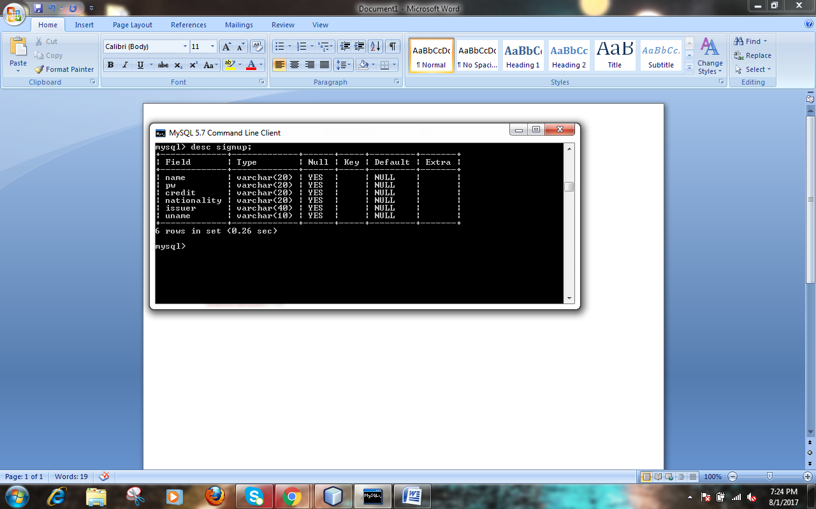

**JAVA**

String name1 = name.getText();

String uname1 = uname.getText();

String pas = pass.getText();

String bank1 =((String)bank.getSelectedItem());

String cr =credit.getText();

String nation =((String)country.getSelectedItem());

try

{Class.forName("java.sql.driver");

Connection con =(Connection)

DriverManager.getConnection("jdbc:mysql://localhost:3306/purcase","root","1234");

Statement stmt =con.createStatement();

int code = JOptionPane.showConfirmDialog(this,"SignUp?", "Confirm Dialogue Box",

JOptionPane.YES_NO_CANCEL_OPTION,JOptionPane.INFORMATION_MESSAGE);

if(code==JOptionPane.YES_OPTION){

String strSQL="INSERT INTO signup(name ,pw, credit ,nationality , issuer , uname) "+

"VALUES("+(name1)+","+(pas)+","+(cr)+","+(nation)+","+(bank1)+","+(uname1)+");";

stmt.executeUpdate(strSQL);

JOptionPane.showMessageDialog(this,"You have been successfully signed up!");

this.dispose();

jFrame2.setVisible(true);

}}

catch(Exception e)

{JOptionPane.showMessageDialog(this,e.getMessage());

}

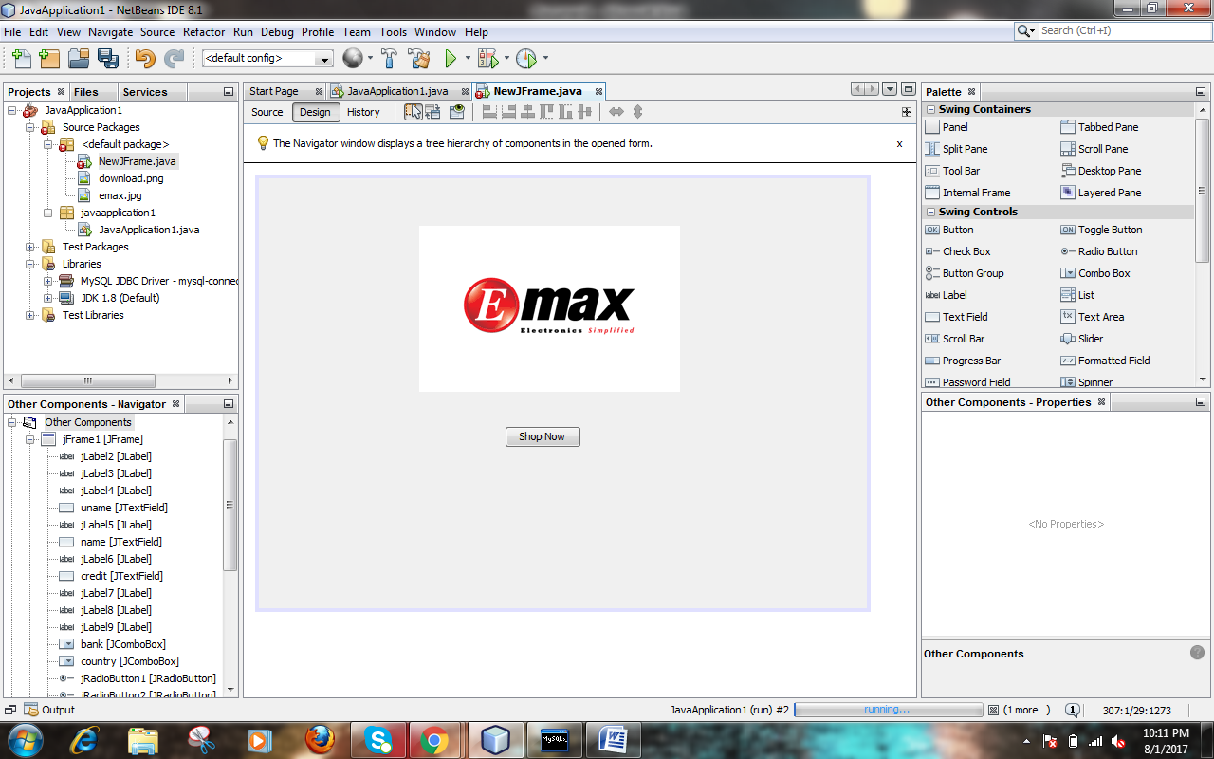

this.dispose();

Signup.setVisible(true);

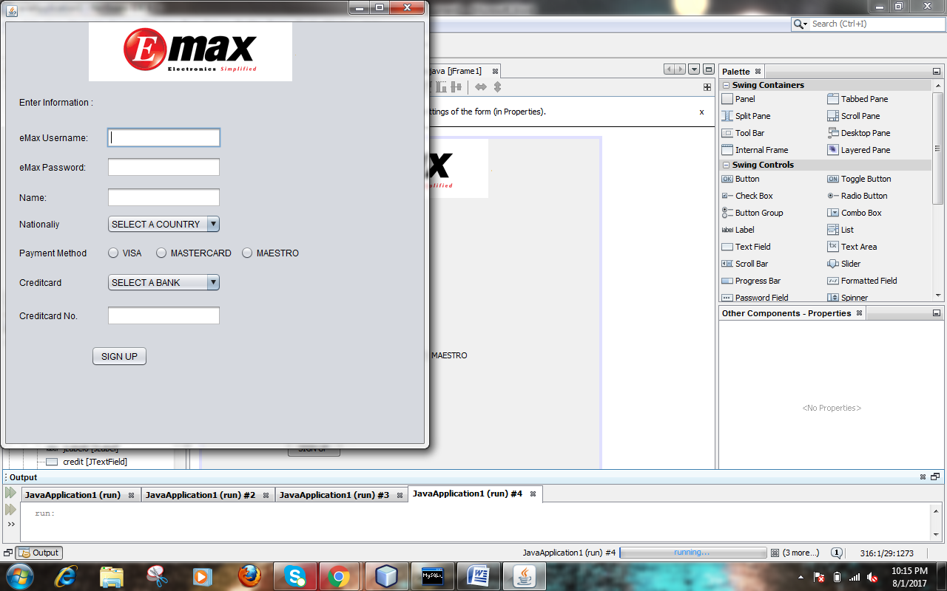

String name1 = name.getText();

String uname1 = uname.getText();

String pas = pass.getText();

String bank1 =((String)bank.getSelectedItem());

String cr =credit.getText();

String nation =((String)country.getSelectedItem());

try

{Class.forName("java.sql.driver");

Connection con =(Connection)

DriverManager.getConnection("jdbc:mysql://localhost:3306/purcase","root","1234");

Statement stmt =con.createStatement();

int code = JOptionPane.showConfirmDialog(this,"SignUp?", "Confirm Dialogue Box",

JOptionPane.YES_NO_CANCEL_OPTION,JOptionPane.INFORMATION_MESSAGE);

if(code==JOptionPane.YES_OPTION){

String strSQL="INSERT INTO signup(name ,pw, credit ,nationality , issuer , uname) "+

"VALUES("+(name1)+","+(pas)+","+(cr)+","+(nation)+","+(bank1)+","+(uname1)+");";

stmt.executeUpdate(strSQL);

JOptionPane.showMessageDialog(this,"You have been successfully signed up!");

this.dispose();

Home.setVisible(true);

}}

catch(Exception e)

{JOptionPane.showMessageDialog(this,e.getMessage());

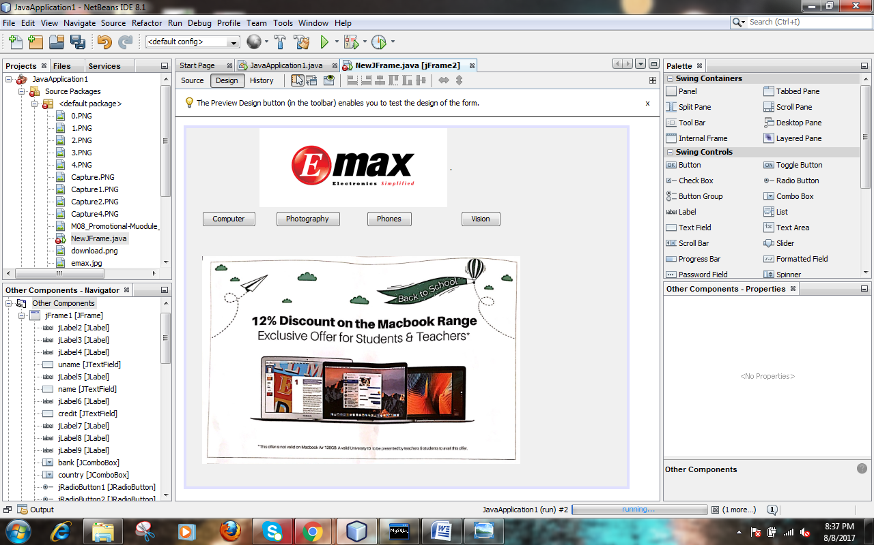

this.dispose();

computer.setVisible(true);

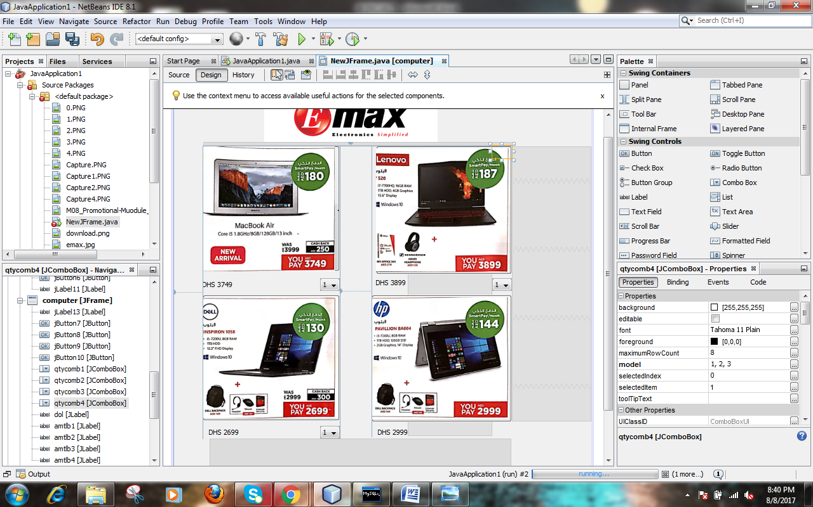

Btn1

double pr =Double.parseDouble(amtlb1.getText());

int qt =Integer.valueOf((String)qtycomb1.getSelectedItem());

double tamt =qt*pr;

dol.setText("Dhs"+tamt);

try

{Class.forName("java.sql.driver");

Connection con =(Connection)

DriverManager.getConnection("jdbc:mysql://localhost:3306/purcase","root","1234");

Statement stmt =con.createStatement();

int code = JOptionPane.showConfirmDialog(this,"Are you sure you want to purchase?", "Confirm Dialogue Box",

JOptionPane.YES_NO_CANCEL_OPTION,JOptionPane.INFORMATION_MESSAGE);

if(code==JOptionPane.YES_OPTION){

String strSQL="INSERT INTO purchase(name ,price, qty ,total) "+

"VALUES("+(name)+","+(pr)+","+(qt)+","+(tamt)+");";

stmt.executeUpdate(strSQL);

JOptionPane.showMessageDialog(this,"Added to your cart");

}}

catch(Exception e)

{JOptionPane.showMessageDialog(this,e.getMessage());

}

Btn2

double pr =Double.parseDouble(amtlb2.getText());

int qt =Integer.valueOf((String)qtycomb2.getSelectedItem());

double tamt =qt*pr;

dol.setText("Dhs"+tamt);

try

{Class.forName("java.sql.driver");

Connection con =(Connection)

DriverManager.getConnection("jdbc:mysql://localhost:3306/purcase","root","1234");

Statement stmt =con.createStatement();

int code = JOptionPane.showConfirmDialog(this,"Are you sure you want to purchase?", "Confirm Dialogue Box",

JOptionPane.YES_NO_CANCEL_OPTION,JOptionPane.INFORMATION_MESSAGE);

if(code==JOptionPane.YES_OPTION){

String strSQL="INSERT INTO purchase(name ,price, qty ,total) "+

"VALUES("+(name)+","+(pr)+","+(qt)+","+(tamt)+");";

stmt.executeUpdate(strSQL);

JOptionPane.showMessageDialog(this,"Added to your cart");

}}

catch(Exception e)

{JOptionPane.showMessageDialog(this,e.getMessage());

} }

Btn3

double pr =Double.parseDouble(amtlb3.getText());

int qt =Integer.valueOf((String)qtycomb3.getSelectedItem());

double tamt =qt*pr;

dol.setText("Dhs"+tamt);

try

{Class.forName("java.sql.driver");

Connection con =(Connection)

DriverManager.getConnection("jdbc:mysql://localhost:3306/purcase","root","1234");

Statement stmt =con.createStatement();

int code = JOptionPane.showConfirmDialog(this,"Are you sure you want to purchase?", "Confirm Dialogue Box",

JOptionPane.YES_NO_CANCEL_OPTION,JOptionPane.INFORMATION_MESSAGE);

if(code==JOptionPane.YES_OPTION){

String strSQL="INSERT INTO purchase(name ,price, qty ,total) "+

"VALUES("+(name)+","+(pr)+","+(qt)+","+(tamt)+");";

stmt.executeUpdate(strSQL);

JOptionPane.showMessageDialog(this,"Added to your cart");

}}catch(Exception e)

{JOptionPane.showMessageDialog(this,e.getMessage());

} }

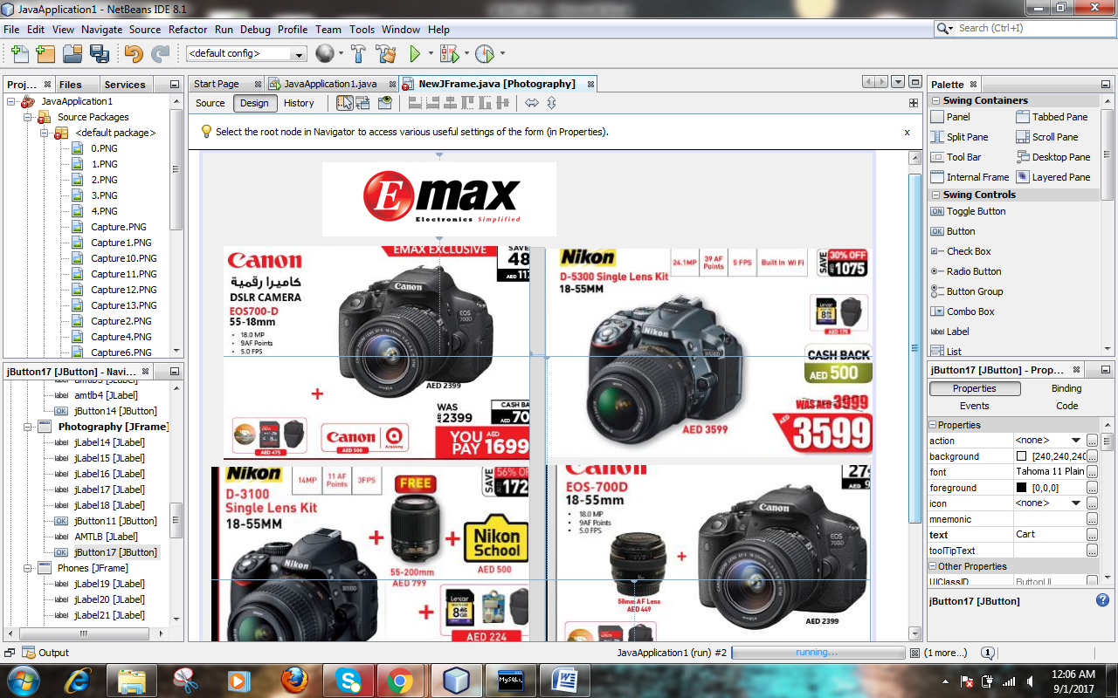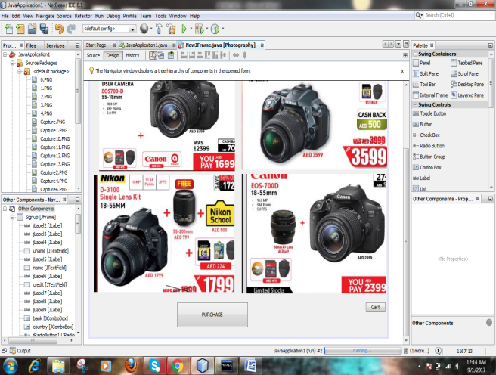

P1btn

double pr =Double.parseDouble(AMTLB.getText());

int qt =Integer.valueOf((String)qtycomb4.getSelectedItem());

double tamt =qt*pr;

dol.setText("Dhs"+tamt);

try

{Class.forName("java.sql.driver");

Connection con =(Connection)

DriverManager.getConnection("jdbc:mysql://localhost:3306/purcase","root","1234");

Statement stmt =con.createStatement();

int code = JOptionPane.showConfirmDialog(this,"Are you sure you want to purchase?", "Confirm Dialogue Box",

JOptionPane.YES_NO_CANCEL_OPTION,JOptionPane.INFORMATION_MESSAGE);

if(code==JOptionPane.YES_OPTION){

String strSQL="INSERT INTO purchase(name ,price, qty ,total) "+

"VALUES("+(name)+","+(pr)+","+(qt)+","+(tamt)+");";

stmt.executeUpdate(strSQL);

JOptionPane.showMessageDialog(this,"Added to your cart");

}}catch(Exception e)

{JOptionPane.showMessageDialog(this,e.getMessage());

} }

C1btn

this.dispose();

Checkout.setVisible(true);

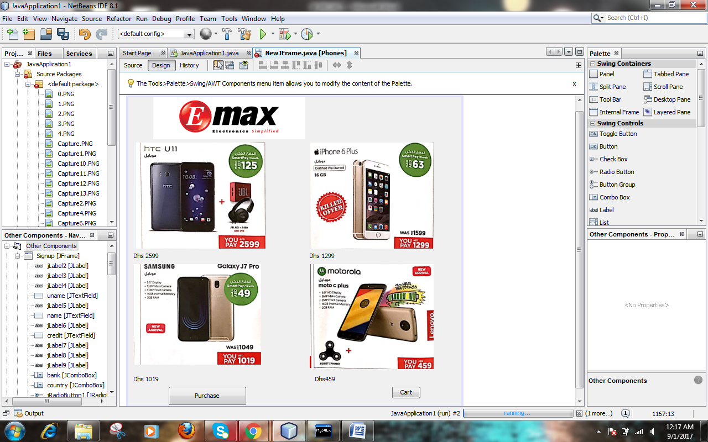

P2btn

// TODO add your handling code here:

double pr =Double.parseDouble(amtlb5.getText());

int qt =Integer.valueOf((String)qtycomb4.getSelectedItem());

double tamt =qt*pr;

dol.setText("Dhs"+tamt);

try

{Class.forName("java.sql.driver");

Connection con =(Connection)

DriverManager.getConnection("jdbc:mysql://localhost:3306/purcase","root","1234");

Statement stmt =con.createStatement();

int code = JOptionPane.showConfirmDialog(this,"Are you sure you want to purchase?", "Confirm Dialogue Box",

JOptionPane.YES_NO_CANCEL_OPTION,JOptionPane.INFORMATION_MESSAGE);

if(code==JOptionPane.YES_OPTION){

String strSQL="INSERT INTO purchase(name ,price, qty ,total) "+

"VALUES("+(name)+","+(pr)+","+(qt)+","+(tamt)+");";

stmt.executeUpdate(strSQL);

JOptionPane.showMessageDialog(this,"Added to your cart");

}}catch(Exception e)

{JOptionPane.showMessageDialog(this,e.getMessage());

} }

C2btn

this.dispose();

Checkout.setVisible(true);

}

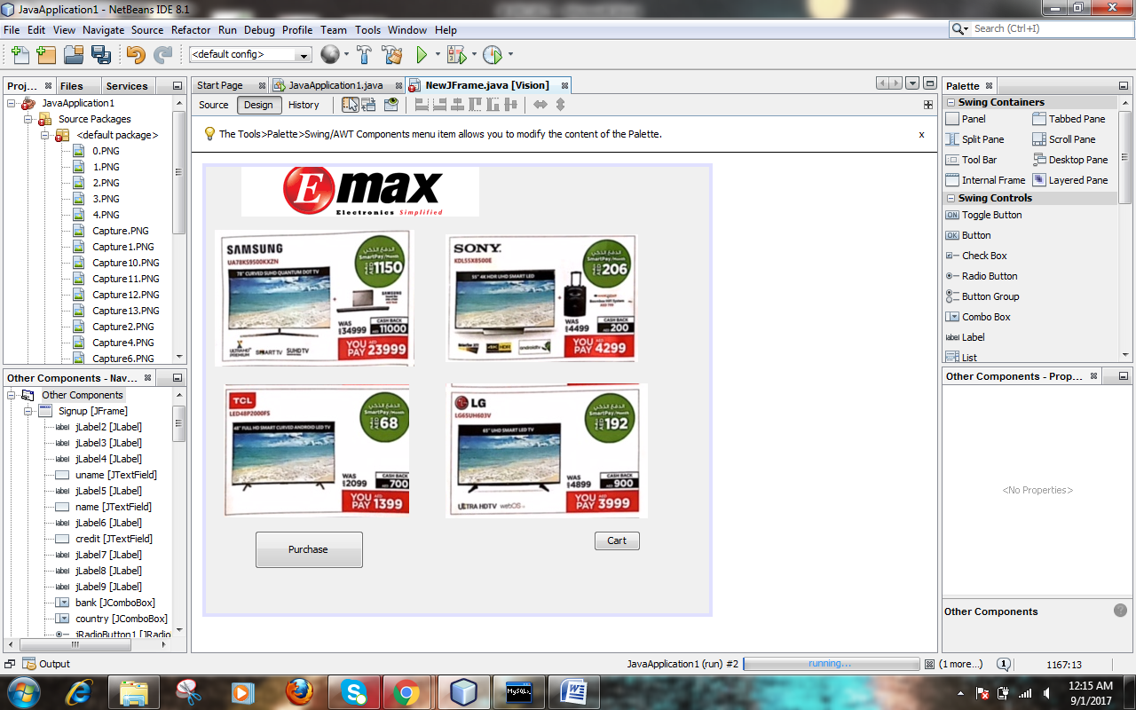

P3btn

// TODO add your handling code here:

double pr =Double.parseDouble(amtlb6.getText());

int qt =Integer.valueOf((String)qtycomb4.getSelectedItem());

double tamt =qt*pr;

dol.setText("Dhs"+tamt);

try

{Class.forName("java.sql.driver");

Connection con =(Connection)

DriverManager.getConnection("jdbc:mysql://localhost:3306/purcase","root","1234");

Statement stmt =con.createStatement();

int code = JOptionPane.showConfirmDialog(this,"Are you sure you want to purchase?", "Confirm Dialogue Box",

JOptionPane.YES_NO_CANCEL_OPTION,JOptionPane.INFORMATION_MESSAGE);

if(code==JOptionPane.YES_OPTION){

String strSQL="INSERT INTO purchase(name ,price, qty ,total) "+

"VALUES("+(name)+","+(pr)+","+(qt)+","+(tamt)+");";

stmt.executeUpdate(strSQL);

JOptionPane.showMessageDialog(this,"Added to your cart");

}}catch(Exception e)

{JOptionPane.showMessageDialog(this,e.getMessage());

}

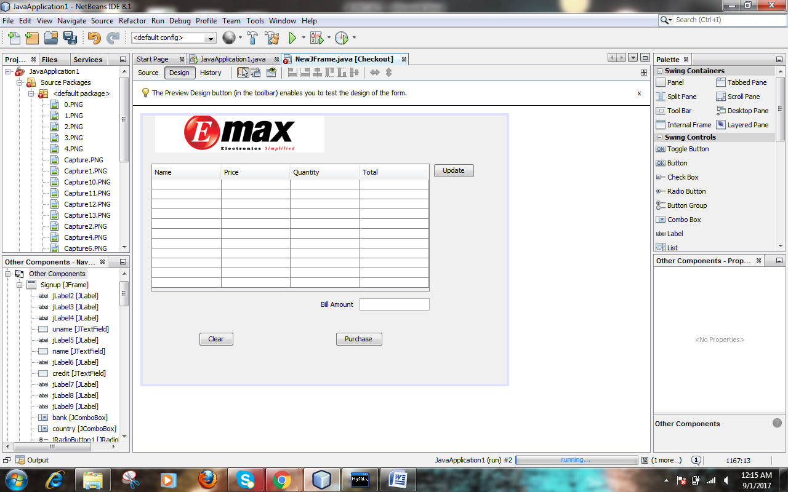

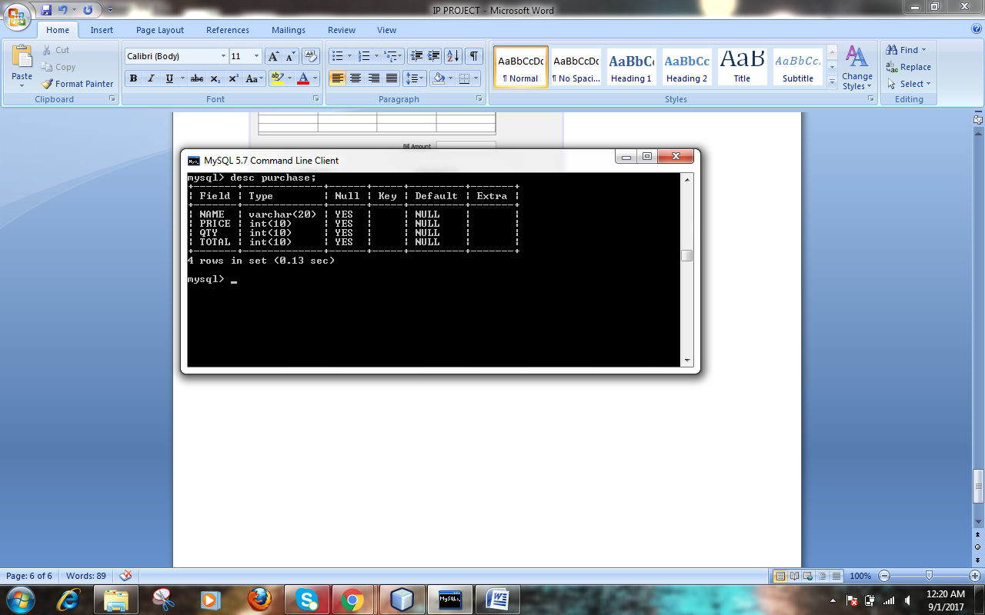

Updatebtn

// TODO add your handling code here:

DefaultTableModel model = (DefaultTableModel)table.getModel();

int row =model.getRowCount();

if(row>0)

for(inti=0;i<row;i++)

model.removeRow(0);

String total="select SUM(total)from purchase;";

String query="SELECT*FROM purchase";

try{

Class.forName("com.mysql.jdbc.Driver")newInstance();

Connection con =(Connection)

DriverManager.getConnection("jdbc:mysql://localhost:3306/purchase","root","1234");

Statement stmt =con.createStatement();

ResultSetrs =stmt.executQuery(query);

while(rs.next()){

String mname=rs.getString("name");

intmprice =rs.getInt("price");

String mqty =rs.getString("qty");

String mtot rs.getString("total");

model.addRow(new object(){mname,mprice,mqty,mtot});

}

Statement stmt1 =con.createStatement();

ResultSet rs1 =stmt1.executeQuery(total);

if (rs1.next())

{

String tota=rs1.getString("SUM(total");

totallb.setText(tata+"AED");

}}

catch(Exception e){

JOptionPane.showMessageDialog(this,e.getMessage());

} } }

Clearbtn

try {

Class.forName("com.mysql.jdbc.Driver").newInstance();

Connection con =(Connection)

DriverManager.getConnecion("jdbc:mysql://localhost:3306/purchase","root","1234");

Statement stmt = con.createStatement();

int opt=JOptionPane.showConfirmDialog(null,"Are You Sure you want to clear purchase?");

if(opt==JOptionPane.YES_OPTION)

{

String strSQL="Delete from purchase;";

introwsEffected=stmt.executeUpadate(strSQL);

if(rowsEffected==0)

JOptionPane.showMessageDialog(this,"No puschases found");

else

JOptionPane.showMessageDialog(this,"Cleared!");

con.close();

stmt.close();

}}

catch(Exception e){

JOptionPane.showMessageDialog(this,e.getMessage());

}}

Purchasebtn

JOptioPane.showMessageDialog(rootPane,"Than you . ", "sucess!!",WIDTH);

{this.dispose();

Home.setVisible(true);

}}

